Exp No: 4
7 SEGMENT DISPLAY USING AT89C51 USING PROTEUS
AIM:
To write an assembly language program for 7 Segment Display Using AT89C51 using Keil and Proteus
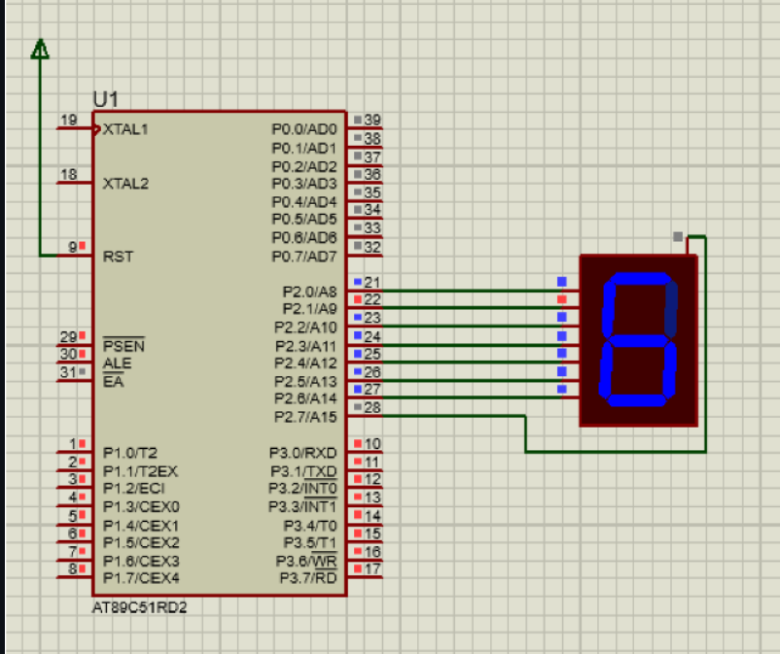

RESULT:
Thus the program has been successfully verified and executed

